**NEWS TRACKER APPLICATION**

**PROJECT REPORT**

**Submitted by**

**TEAM ID: PNT2022TMID04482**

**SRI RAAM (737819CSR183)**

**VISHAL RUPAK V R (737819CSR223)**

**VIGNESH L (737819CSR220)**

**VIGNESH S(737819CSR219)**

**NO TITLE**

### INTRODUCTION

* 1. Project Overview
  2. Purpose

### LITERATURE SURVEY

* 1. Existing problem
  2. References
  3. Problem Statement Definition

### IDEATION & PROPOSED SOLUTION

* 1. Empathy Map Canvas
  2. Ideation & Brainstorming
  3. Proposed Solution
  4. Problem Solution fit

### REQUIREMENT ANALYSIS

* 1. Functional requirement
  2. Non-Functional requirements

### PROJECT DESIGN

* 1. Data Flow Diagrams
  2. Solution & Technical Architecture
  3. User Stories

### PROJECT PLANNING & SCHEDULING

* 1. Sprint Planning & Estimation
  2. Sprint Delivery Schedule
  3. Reports from JIRA

### CODING & SOLUTIONING (

1. **ADVANTAGES & DISADVANTAGES**

### CONCLUSION

1. **FUTURE SCOPE**

### APPENDIX

GitHub & Project Demo Link

# INTRODUCTION

## Project Overview

As our lives are very busy these days, we often feel we need more than 24 hrs a day to cope up with everything we have in our schedule. Well, that's not possible but reducing the time by changing the conventional method of reading news can help. Just tell us what market news you're interested in and get a quick peek for the day. Only read what you feel relevant and save your time. This app helps you to query for all information about Indices, Commodities, Currencies, Futures, Rates, Bonds, etc… as on official websites. News Tracker is an application that primarily focuses on enhancing and optimizing the way of user interaction with the news stories. It is more user friendly in a way that a user can personalise his/her own interests in this application. The study process began with how other applications developed with respect to personalisation and giving users a curated content. This step allowed the study analysis identify the disadvantages and make it as advantages in this application. The idea of personalisation is that it keeps track of the user's interests and accordingly change the home page for the users to give them a personalised experience based on what they set as their preferences. The application also has an added advantage that any user using this application might not be able to feel discomfort as there are no advertisments which many applications failed to meet up the expectations of a user. The application stands out off the crowd in terms of personalisation, better search and able to view in multiple languages.

## Purpose

News tracker serves the purpose of delivering a better application to the users and enhanced user experience and user interface. The ultimate purpose is giving the user a personaslised application with an ability to better search and this application doesn't function on one language and thus enabling users to use this application worldwide. The users should be displayed with clean, personalised content on the home page with zero advertisements. The need for this project is to deliver news stories without any distractions and getting to see the content only the users like.

# LITERATURE SURVEY

## Existing Problem

Newspapers were the leading source and first physical source of news for people. Even though the habit of reading newspapers has decreased significantly, the information sector is still alive and well.

Several advancements in the technology sector first enabled smartphones to display latest and updated news on reader’s demand. Personalisation of news access should extend beyond ‘what’ the user sees to ‘how’ they access it. Popular applications like **Google News**, **BBC** and **DailyHunt** provide personalised and curated content to users. Users select topics to follow and the system generates a news feed for them to read and also provides a summary for each article.

The personalisation news apps can be achieved by making the User Interface adaptable. An adaptable user interface will allow the system to adapt to the way the users read and provide summaries of articles.

### Existing System:

Google News:

* + - Under each headline, the “Full Coverage” button lets users round up coverage from the best news sources on a given topic—something discerning readers value in an era of intense partisanship and concern about biased reporting.
    - Ability to subscribe to specific news sources and read them directly from the app.
    - Option to purchase premium subscriptions to news outlets.
    - Interconnected updates on the latest developments for existing news updates.

## References

* + - https://news.google.com
    - [https://www.msn.com/](http://www.msn.com/)
    - <http://news.yahoo.com/>
    - <http://twitter.com/>

## Problem Statement Definition

News articles are accessed via smartphones and tablets more now than ever. This has created

a need for providing personalised feed of news articles for users. A recent study by Reuters Institute for the Study of Journalism’s Digital News Report said that about 82 percent of Indians read the news online, out of which 73 percent do it on their smartphones.

Curated news feed has been widely used as the tool for sourcing a variety of content from different sources on a report and providing a 360-degree review of the story. The demand for news curation has increased over the years and users looks for SMEs to help them find quality and informative content without having to spend much time browsing or scan multiple articles themselves.

# IDEATION & PROPOSED SOLUTION

## Empathy Map Canvas

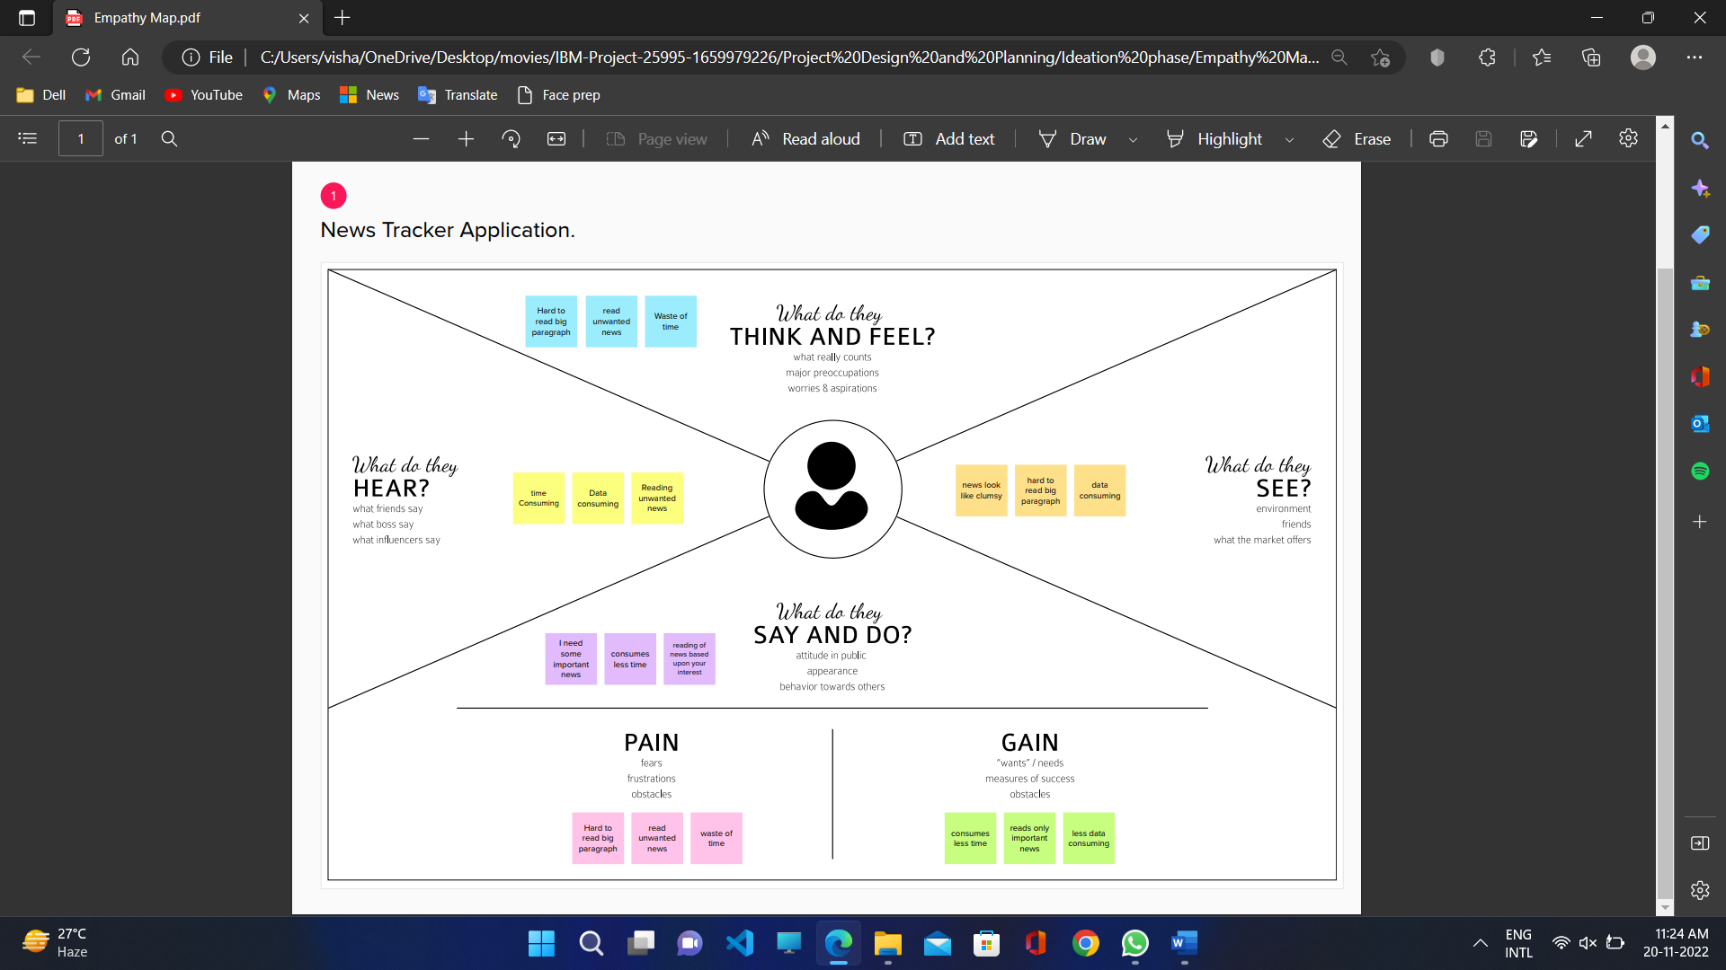

* 1. **Ideation and Brainstorming**

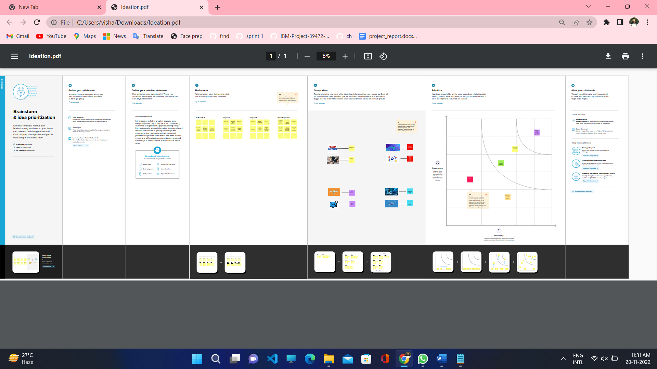

## Proposed Solution:

Project team shall fill the following information in proposed solution template.

|  |  |  |
| --- | --- | --- |
| **S.No.** | **Parameter** | **Description** |
| 1. | Problem Statement (Problem to be solved) | Most people don’t like to carry a newspaper with them. Some people want them to be updated only in the area they are interested in. |
| 2. | Idea / Solution description | 1. A cloud-based web application which enables the user to get the news as per their interests, choices andlocation. 2. News will be filtered as per the user’s wish and it will be displayed to the user. |
| 3. | Novelty / Uniqueness | 1. Integrate the application with news APIs and store the data in the database. 2. This application provides users with a trusted and secured ecosystem. News shared through the application is original and spam free. 3. The database will have all the details and the user can search the news by using a search bar. 4. Detecting fake news. |
| 4. | Social Impact / Customer Satisfaction | 1. Since we are using the News API, the news will be reliable and accurate. 2. The customer can be aware of recent happenings. 3. The customer will be finally able to view news without ads. |
| 5. | Business Model (Revenue Model) | The revenue stream can be from the news channels and news sites whose news will be published in this application. Based on the number of users who view a particular news, the news channel that published that news article will have to pay a small amount as commission. |

|  |  |  |
| --- | --- | --- |
|  |  | * Multiplatform Support * Design consistent experience |
| 6. | Scalability of the Solution | As it was an application-based project, correct ideation and execution can develop an application with no bugs and errors, so that the user might like our application and some might suggest and share it to their surroundings, resulting in an increase in our application insights.. |

**Problem Solution Fit**

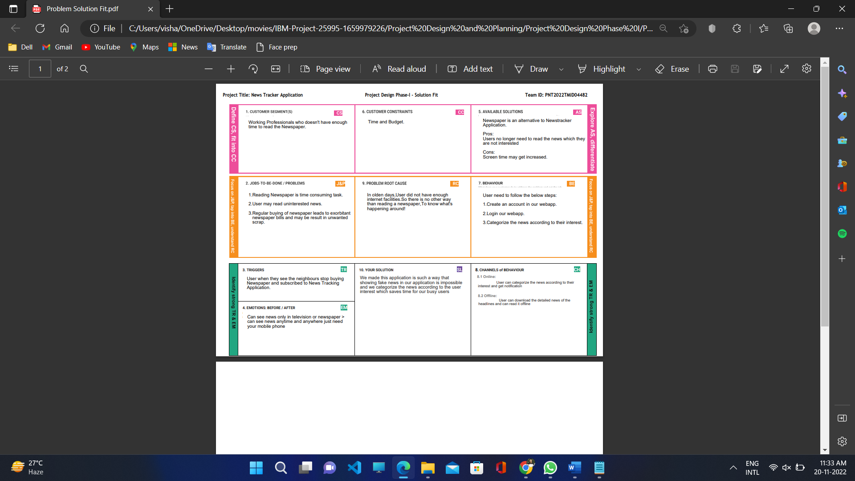

# REQUIREMENT ANALYSIS

## Functional Requirements:

Following are the functional requirements of the proposed solution.

|  |  |  |
| --- | --- | --- |
| **FR No.** | **Functional Requirement (Epic)** | **Sub Requirement (Story / Sub-Task)** |
| FR-1 | User Registration | Registration through Gmail. Registration through Phone number |
| FR-2 | User Confirmation | Confirmation via Email. Confirmation via OTP. |
| FR-3 | User login | Login through browser directly by entering username and password. |
| FR-4 | Home Page | Search Bar, profile, Menu Bar |
| FR-5 | Profile | Name, Venue, Pin Code, Favourites. |
| FR-6 | Menu Bar | Profile Edit, Categories, Settings, Help, About us. |
| FR-7 | Settings | Notification, Language, Location, Log out |
| FR-8 | User interaction | Done through user interface between client and server View the related news by subscripted or requested page |

## Non-functional Requirements:

Following are the non-functional requirements of the proposed solution.

|  |  |  |
| --- | --- | --- |
| **FR No.** | **Non-Functional Requirement** | **Description** |
| NFR-1 | **Usability** | Usability contributes to the effectiveness, efficiency  and satisfaction in which specified users achieve specified goals. |
| NFR-2 | **Security** | Security focuses on the software security in mobile app on various platforms such us Android, iOS. They designed and developed to run on frameworks and anticipated set of users. |
| NFR-3 | **Reliability** | Reliability is the probability of a piece of software operating without any failure while in a specified environment over a period of time. |
| NFR-4 | **Performance** | Performance of the application is notable through load time, crash report, device information, screening resolution & OS. These metrics are also  used for improving the testing process. |
| NFR-5 | **Availability** | Availability is a measure used to evaluate whether  an application is functioning properly &usable to meet the requirements of an individual. |
| NFR-6 | **Scalability** | Since the entire business runs in cloud, scalability won’t be an issue vertically & horizontally there by reducing the overall operational expenditure. |

# PROJECT DESIGN

## Data Flow Diagrams

### Data Flow Diagrams:

A Data Flow Diagram (DFD) is a traditional visual representation of the information flows within a system. A neat and clear DFD can depict the right amount of the system requirement graphically. It shows how data enters and leaves the system, what changes the information, and where data is stored.

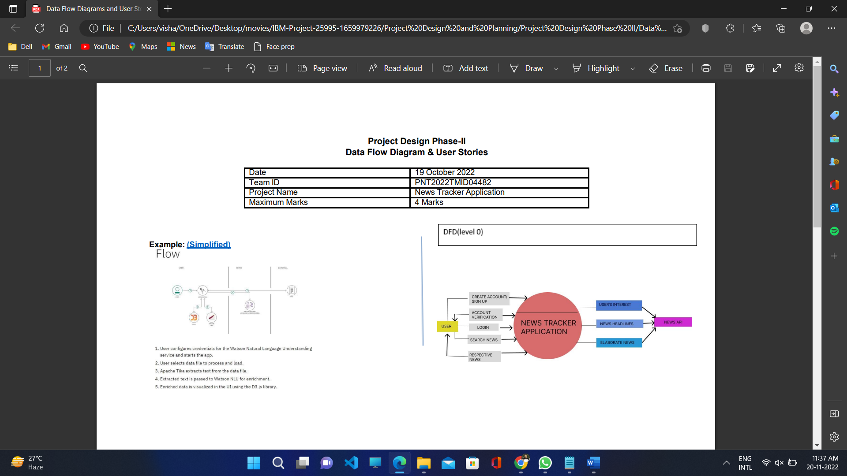

## Solution & Technical Architecture

Solution Architecture: Solution architecture is a complex process – with many sub-processes

* that bridges the gap between business problems and technology solutions. Its goals are to: • Find the best tech solution to solve existing business problems.
  + Describe the structure, characteristics, behaviour, and other aspects of the software to project stakeholders.
  + Define features, development phases, and solution requirements to the project.
* Provide specifications according to which the solution is defined, managed, and delivered to the customers.

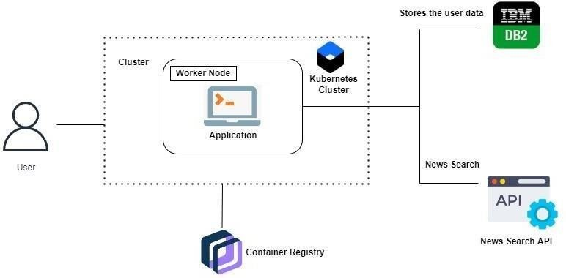

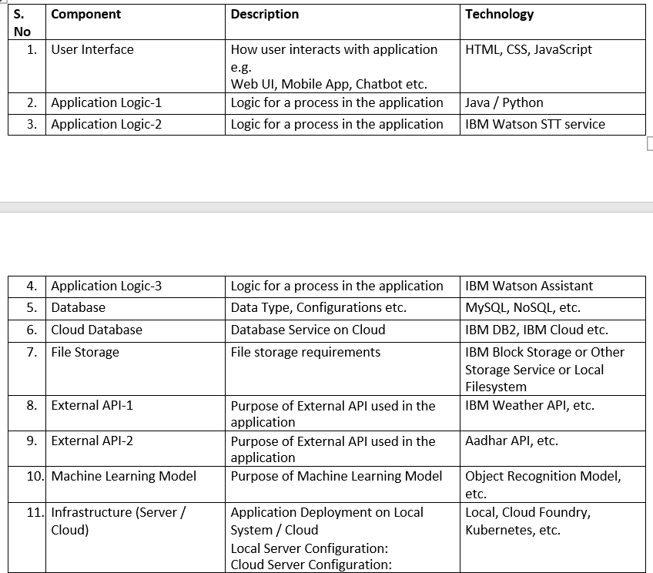**Components and Technologies**

## Application Characteristics:

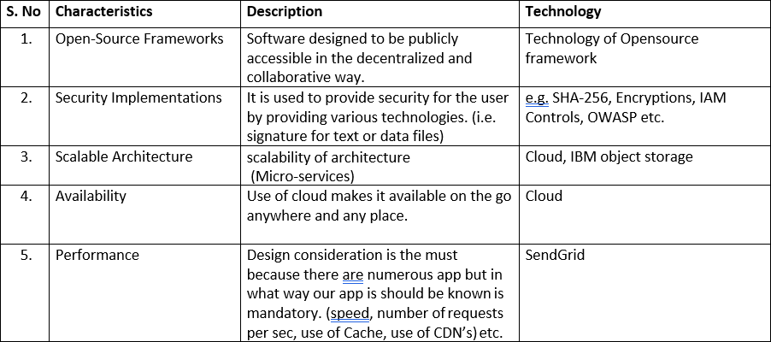

* 1. **User Stories**

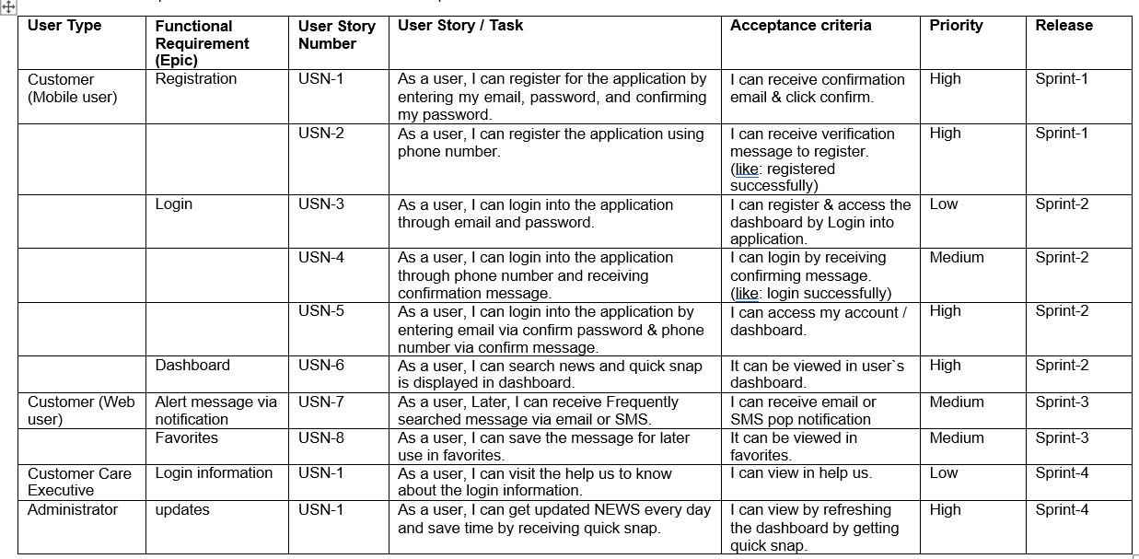

# 6.PROJECT PLANNING & SCHEDULING

## Sprint Planning & Estimation

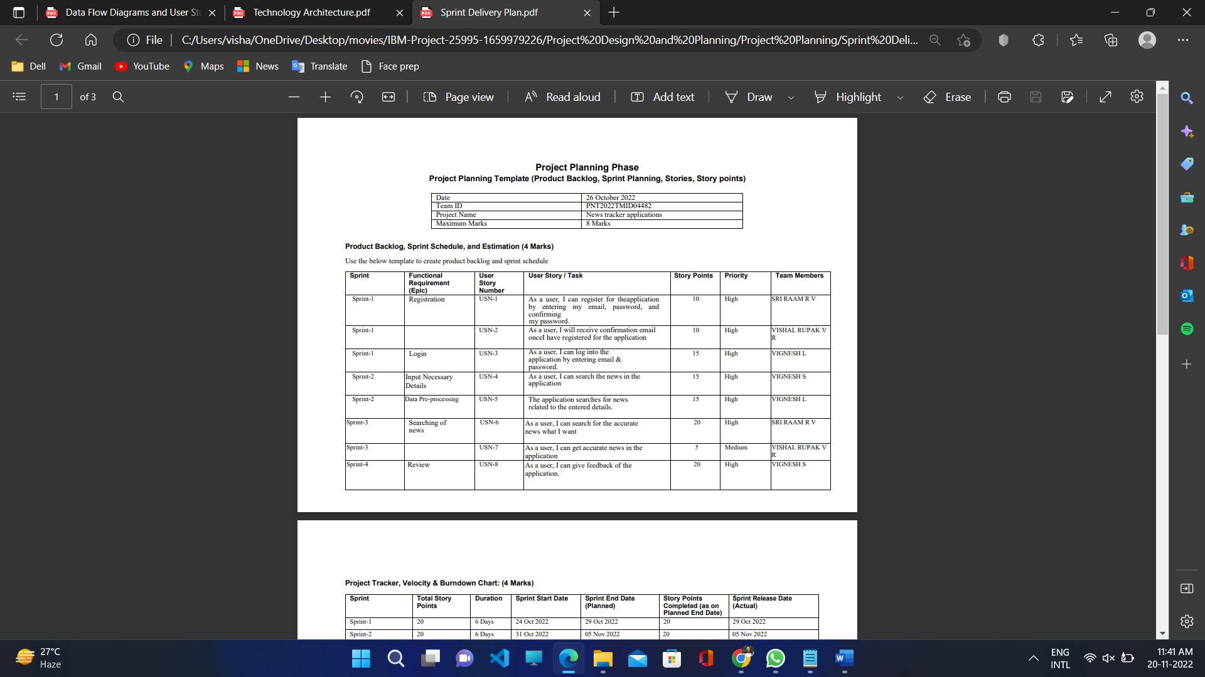

**Sprint Delivery Schedule**

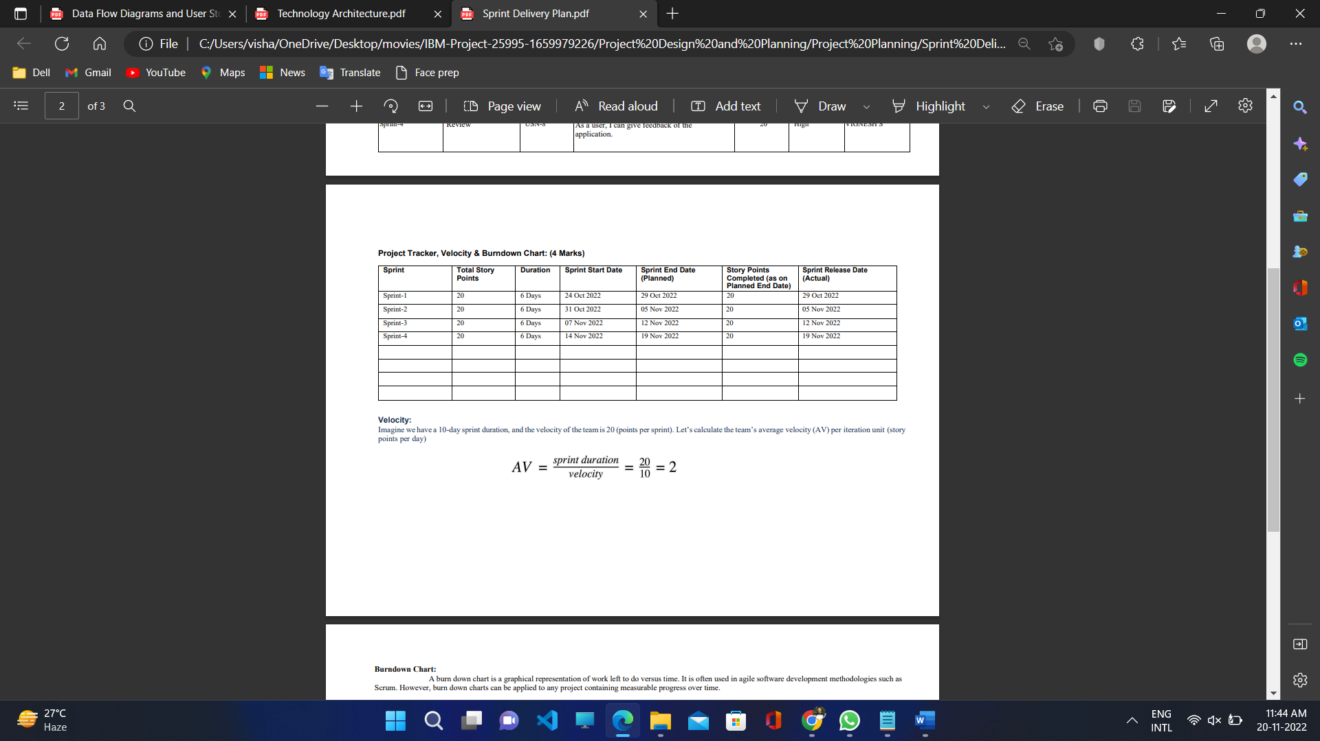

* 1. **Reports from JIRA**

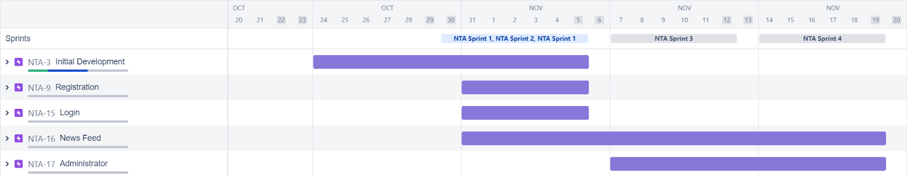

# CODING & SOLUTIONING

* 1. **ADVANTAGES & DISADVANTAGES**

## Advantages

* + - The user's are able to keep track of their favourite sources, categories or authors with a few clicks
    - The search bar allows the user to query results based on a large number of options and combinations
    - Chatbot integration for assistance in account creation and preference setting
    - Multiple categories and endless articles fetched using newsapi

## Disadvantages

* + - Since the news articles are fetch from an external API, the validity of the data cannot be guaranteed
    - Users have to give accurate keywords to search for results

# CONCLUSION

With the help of the internet and external application programming interfaces, it is possible to keep the users informed of the current affairs. With a vast database of articles and references, users are even encouraged to read more.

As news is increasingly accessed on smartphones and tablets, the need for personalising news app interactions is apparent. Users' demands and requirements for personalisation increases day by day. The application's personalisation feature will attract users to spend more time browsing through articles.

And finally, the search bar, will help readers located certain articles based on multiple filters like date, source, language and author to give the users a better user experience.

# FUTURE SCOPE

* + - Provide filter options for user's to track articles
    - Modification and deletion of preferences
    - Location based rendering of articles
    - Allowing users to report falsified and misleading information

# APPENDIX

**GitHub Link: https://github.com/IBM-EPBL/IBM-Project-25995-1659979226**